**MTH202 Assignment #1 Spring 2022**

***Name: Abdul Rehman.***

***VU-ID: BC200403287.***

**Question 1: Marks: 5**

Use truth table to determine the argument form



is valid or invalid. Also identify premises, conclusion and critical rows.

**Solution:**

|  |  |  |  |  |  |
| --- | --- | --- | --- | --- | --- |
|  |  | ***Premises*** | | ***Conclusion*** |  |
| **p** | **q** | ***p*  *q*** | ***~q*** | ***~p*** |  |
| T | T | T | F | F |  |
| T | F | F | T | F |  |
| F | T | F | F | T |  |
| F | F | T | T | T | Critical Row |

**As the condition is True in critical row therefore, the argument is valid.**

**Question 2: Marks: 10**



**Solution:**

**Given:**

U = {0, 1, 2, 3, 4, ………, 14}.

A = {2, 3, 5, 6, 11, 13}.

B = {0, 2, 4, 6, 8, 10, 12, 14}.



B - A = {0, 2, 4, 6, 8, 10, 12, 14} - {2, 3, 5, 6, 11, 13}.

**B – A = {0, 4, 6, 8, 10, 12, 14}.**

**Venn Diagram of B-A:**

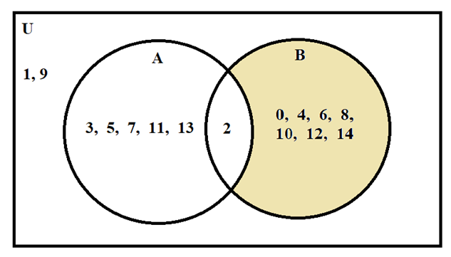

Bc = U -B = {0, 1, 2, 3, 4, ………, 14} - {0, 2, 4, 6, 8, 10, 12, 14}.

**Bc = {1, 3, 5, 7, 9, 11, 13}.**

Bc  A = {1, 3, 5, 7, 11, 13}  {2, 3, 5, 7, 11, 13}.

**Bc  A = {3, 5, 7, 11, 13}.**

**Venn Diagram of Bc****A:**

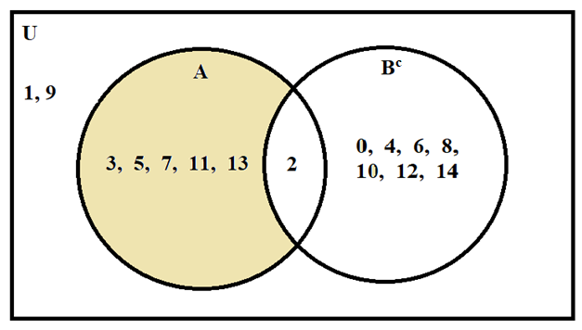



|  |  |  |  |  |  |  |
| --- | --- | --- | --- | --- | --- | --- |
| **U** | **A** | **B** | ***Ac*** | ***Bc*** | ***Ac*  *B*** | ***A*  *Bc*** |
| 1 | 1 | 1 | 0 | 0 | 1 | 0 |
| 1 | 1 | 0 | 0 | 1 | 0 | 1 |
| 1 | 0 | 1 | 1 | 0 | 1 | 0 |
| 1 | 0 | 0 | 1 | 1 | 1 | 0 |